Create HTML Pages

|  |  |
| --- | --- |
| **Date** | 03 -09- 2022 |
| **Team ID** | PNT2022TMID13897 |
| **Project name** | AI-powered Nutrition Analyzer for Fitness Enthusiasts |

* We use HTML to create the front-end part of the web page.
* Here, we have created 3 HTML pages- home.html, image.html, imageprediction.html, and 0.html.
* home.html displays the home page.
* image.html is used for uploading the image
* imageprediction.html will showcase the out[put](https://www.w3schools.com/html/)
* 0.html is to showcase the result. It tells the action to be performed on imageprediction.html while showcasing the result.
* We a[lso u](https://www.w3schools.com/css/)s[e J](https://www.w3schools.com/js/DEFAULT.asp)avaScript-main.js and CSS-main.css to enhance our functionality and view of HTML pages. Link :CSS , JS

Home.html looks like this



image.html

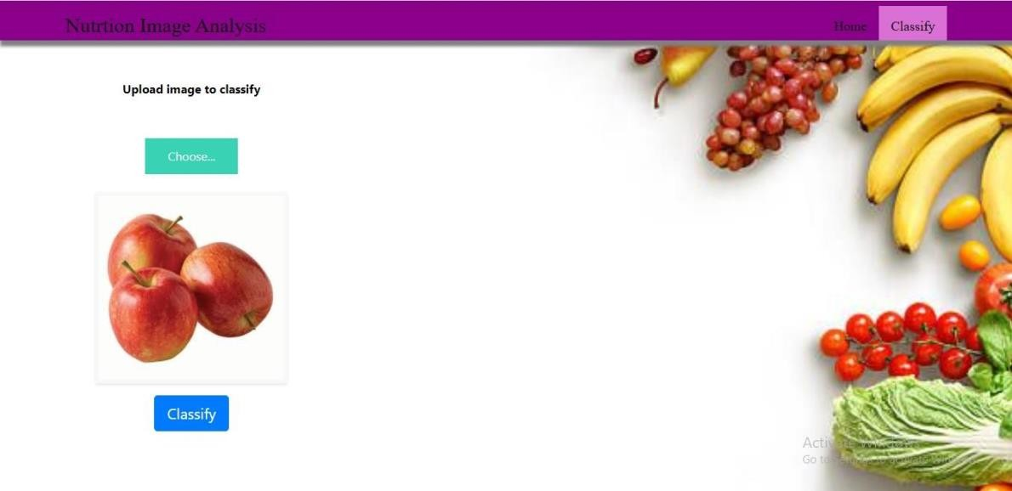

Imageprediction.html

